Brand Personality
NENA Skincare
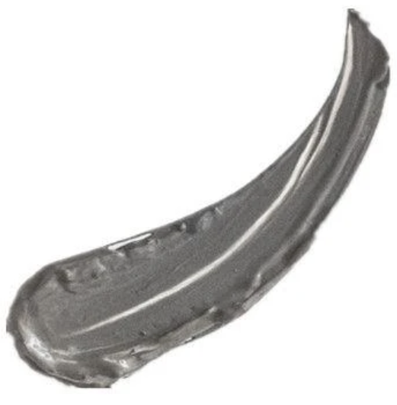
Natalie Gruenwald, Gabby Bajorek, Ben Wolfer
April 2020

Overview

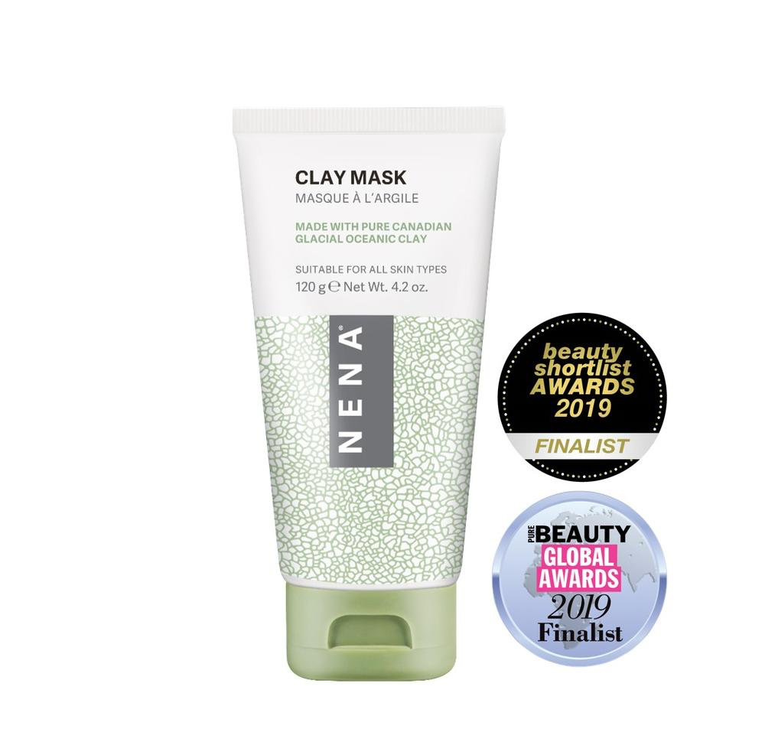

The Glacial Clay Mask is the heart of NENA

Skincare, taking pride in its Canadian origins

and the embodiment of the

Brand personality. The mask’s light

green color communicates the brand’s

organic values and nature.

NENA Skincare likes to educate their users using informative blog posts, and organic
Imagery.

Brand Traits

Informative but not academic

Natural but not unrefined

High Quality but not overly priced

Feminine but not exclusive

Modern but not alienating

Prestigious but not exclusive

To the point but not Overly
Simplistic

Voice

The voice of NENA is very passionate, informative, and to the point. NENA enjoys sharing
its deep Canadian roots with its customers, how it came to be, and what it is.
The voice of NENA cares for its customers and wants to help them find the skincare product
that is best for them no matter how educated they are on skincare.

Copy Examples

Once you complete your order
Congratulations! You are on your way to healthier skin!
Error Message
Oops! Looks like you forgot to enter your address.
Influencer Post
Tie up your hair and get ready to treat yourself to
an at-home spa day. Here’s @influencer with flawless
skin after using our #NENAClayMask.
Marketing Copy
When we use a natural ingredient as powerful as
glacial oceanic clay, there’s no need to add in
unnecessary fillers or harsh chemicals to make our
products benefit your skin.

